Welcome to

Bartlett!

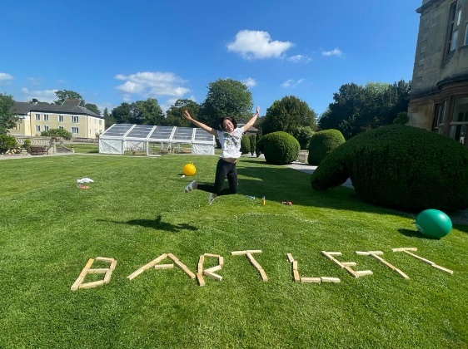

Everything you need to know about…

* Daily Routines
* Weekend Routines
* Laundry
* Phones
* Food
* Health
* Personal Space
* Dorm Tidy
* Bartlett Family Time
* Who to talk to

Daily Routine for a Junior

7.00am Wake up! Don’t worry about setting an alarm! We will come and wake you up.

7.00-7.45am Get ready for school! Get dressed, brush your teeth, and make sure your bag is packed and your room is tidy!

When you’re ready, you can have your phone until breakfast!

7.45am Breakfast! We will go down to the dining hall together.

8.15am Off to school!

5.30pm (4pm on Fridays) School is over! We will come pick you up to go back to Bartlett for showers!

6.00pm Supper time! We will go down to the dining hall together.

6.40pm Bartlett family time and time to prepare for the next school day!

7.30pm Time to hand in your phone and other devices!

8.15pm Get ready for bed!

8.45pm Lights out! Good night!

Daily Routine for a Senior

7.00am Wake up! Don’t worry about setting an alarm! We will come and wake you up.

7.00-7.45am Get ready for school! Get dressed, brush your teeth, and make sure your bag is packed and your room is tidy!

When you’re ready, you can have your phone!

7.45am Breakfast! We will go down to the dining hall together.

8.30am Off to school! Don’t forget to hand in your phone!

6.00pm Supper time! We will go down to the dining hall together.

6.40pm Bartlett family time and time to prepare for the next school day!

8.15 (Y7) / 9.00pm (Y8) Time to hand in your phone and other devices!

8.45 (Y7) / 9.00pm (Y8) Get ready for bed!

9.15 (Y7) / 9.30pm (Y8) Lights out! Good night!

Weekend Routine

On weekends, we spend time together, do lots of fun activities and often go on trips!

Saturday

7.15 Wake up!

8.15 Breakfast

9.00 Prep Time! We’ll go downstairs to one of the classrooms to do our prep.

12.00 Lunch!

Afternoon In the afternoon, you can go to Henleaze in groups to stock up on snacks! We will also go on trips together!

6.00pm Supper time!

Evening Bartlett family time! It’s noodle night and we watch a film together.

Sunday

Morning Sunday mornings are very relaxed! You can speak to your family, play with your friends, or spend some time on your phone.

11.00 Brunch!

Afternoon In the afternoon, you can go to Henleaze in groups to stock up on snacks! We will also go on trips together!

6.00pm Supper time!

Evening Bartlett family time and time to prepare for the next school day.

Weekly Routine

If you want to find out more about your weekly routine, have a look on the activities board! You’ll find out when have our house meetings, noodle nights and other activities!

Always keep an eye out for the notice board next to the office to find out everything you need to know for the day!

Laundry

We are very lucky in Bartlett to have our clothes washed in school! Keep an eye out for the bags and signs telling you what to wash!

If you need anything in an emergency for the next day, use the emergency wash and staff will wash it for you!

Phones

In Bartlett, we are more than happy for you to use your phones, but we ask that they go away at night in our common room cupboard and that they are not taken into school with you!

Do not take pictures of others without their permission!

Of course, you will be able to speak to your family on the phone. On weekdays you can speak to them after getting ready in the morning before breakfast and in the evenings after supper. On the weekends, phone times are more flexible, so you’ll have plenty of time then too!

Food

Whilst you are at Badminton, all your food is provided to you.

In Bartlett, there’s an opportunity on weekends to get some snacks from the local shops in Henleaze and we sometimes have Year Group Treats where you can choose a takeaway.

We also have a tuck shop with plenty of treats to choose from! The money from tuck shop goes towards our charity of the year!

We also love to bake and have weekly noodle nights.

Health

If you are ever feeling unwell in Bartlett, then we are here to help, just let us know!

If you feel ill whilst at school, then the nurses in the Health Centre are there to look after you!

You can also do your own bit to stay healthy by putting lots of fruit and vegetables in your diet and staying active by taking part in sports during and after school!

Personal Space

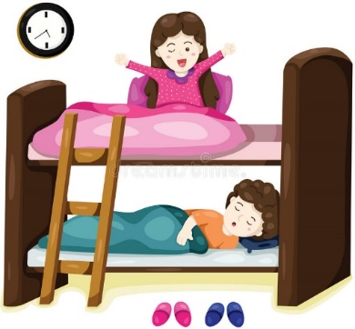Even though we share rooms here in Bartlett, you have your own wardrobe, draws and locked area so you can keep organised!

We also have a quiet room, so if you ever want some time out then there is lots of room to relax!

Dorm Tidy

As a family it is important to remember that we are living in a close environment, so keeping your area tidy is important! Every day we check your room and if you get full marks every day for a week then you will get a sweet treat and even a dorm sleepover at the end of term!

Bartlett Family Time

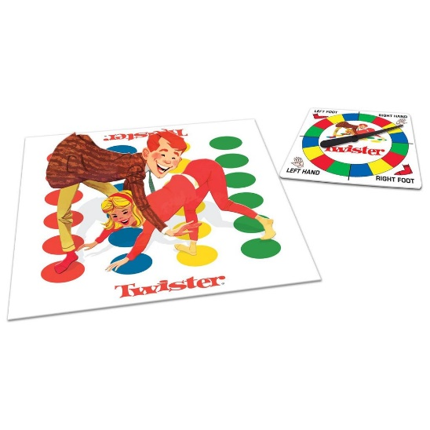In Bartlett, we value our family time in the evenings and on the weekends. You are always welcome to socialise in one of the two common rooms and we have lots of games for you to play with.

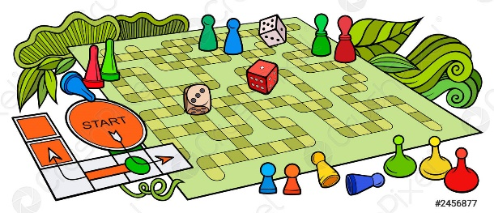

Who to talk to…

No matter how you are feeling, there is always someone to chat to!

Bartlett Staff Mentors

The Health Centre Counsellors

Buddies Teachers

Peer Friends

**No question is too silly or too crazy! WE ARE HERE TO HELP! And will take you seriously!**

DOs and DON’Ts

DO have fun and enjoy yourself!

DON’T forget to name your clothes and belongings! There are lots of us in Bartlett!

DO remember to sign in and out when you’re leaving or arriving into Bartlett

DON’T spend too much time on your phone, we have plenty of games!

DO listen to Bartlett staff; we are here to keep you safe and happy!

DON’T snack before dinner!

DO practise the things you love – we have a music room and common rooms!

DON’T leave your belongings around the house, we don’t want you to lose them!

DO speak to someone if you are ever worried, stressed or sad. We all feel like that sometimes!

WELCOME TO OUR BARTLETT FAMILY!!

😊