Making a parachute

Does the size of a parachute make a difference to how fast it falls?

Apparatus  • Piece of plastic • 10 g mass  • Scissors • Paper clips  • Metre rule • Stopclock  • Cotton thread • Calculator  Method  1 Cut out a square 60 cm  2 cm from a piece of plastic.  2 Cut four pieces of cotton 30 cm long, and tie a paper clip to each one.  3 Unbend the paper clips and push one through each corner of your plastic.  4 Tie the other ends of the thread to your mass. Now your parachute is ready to test.  5 Drop your parachute and time how long it takes to get to the ground. Write your result in the table below. | 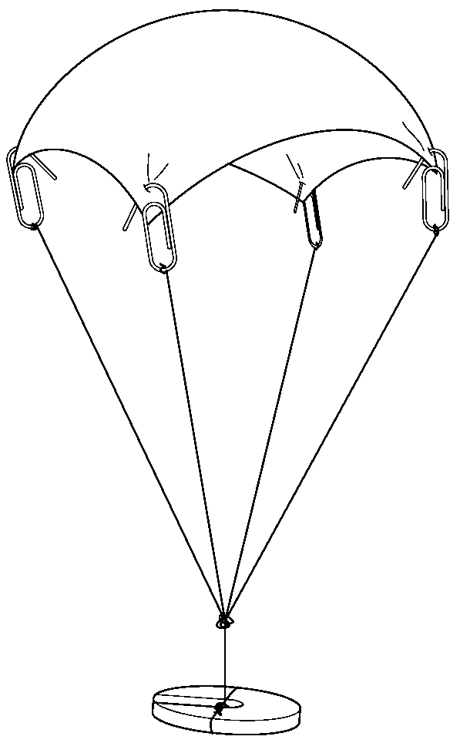
6 Drop the parachute twice more, then work out the mean time for your three drops. Make sure you drop it from the same height each time.
7 Repeat steps 1 to 6 for smaller parachutes. The measurements you need are in the table.

Recording your results
Size of | Time to fall (s) |  |  | Mean time to
parachute | 1st drop | 2nd drop | 3rd drop | fall (s)
60 cm  60 cm
50 cm  50 cm
40 cm  40 cm
30 cm  30 cm

Find the mean by adding up all three results, then divide your answer by 3.

Considering your results/conclusions
Complete these sentences, using the words from the box.

air area resistance slower

Bigger parachutes fall ___________________ than small ones. This is because they have more ___________________ ___________________ than smaller ones. This is because they have a bigger ___________________ .

Evaluation
Why do you think you had to test each parachute three times?

________________________________________________________________________

________________________________________________________________________

________________________________________________________________________

Is there any way that you could improve your experiment?

________________________________________________________________________

________________________________________________________________________

________________________________________________________________________

________________________________________________________________________

________________________________________________________________________

________________________________________________________________________

