# Telescopes - an introduction

Mankind has always been fascinated by the view that the night sky offers. Everything we know about the far reaches of space has been discovered by subsequent generations of curious star-gazers doing just the same. Now, with modern technology, we can look further than ever before, with more reliability and across a wider spectrum of light.

* [Gallery of images from the Hubble Website](http://hubblesite.org/gallery/album/exotic/)
* [How telescopes work](http://www.howstuffworks.com)
* Topics 3.5, 3.6 in the AQA textbooks

# Why we can see further now than ever before...

You will already be well aware that you can't see stars during the day or on a cloudy night! Other factors that make observing the night sky difficult are:

* Air pollution (particulates in the air absorb and reflect the light)
* Light pollution (you will see more stars in the country than if you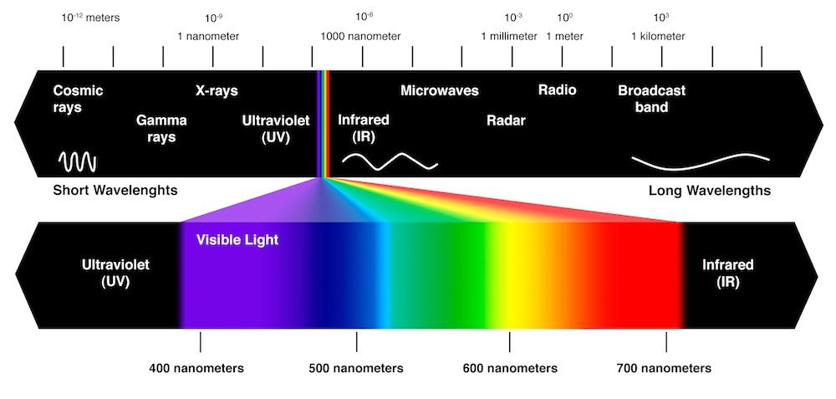 look up from the city due to the effects of streetlighting)
* Atmospheric effects (refraction due to layers of air at different temperatures - this is why stars appear to 'twinkle')
* Humidity

# Why we can see more than ever before...

Until recently, the only part of the electromagnetic spectrum that we could detect was the tiny portion of it occupied by visible light. Now, modern telescopes can be designed with detectors on board that will survey other parts of the EM spectrum as it is emitted by objects in space. Being able to see all these parts of the EM spectrum reveals much more of the story of the Universe than visible light could ever tell us on its own.

Of special interest are:

* Radio telescopes
* X-ray telescopes
* Microwave telescopes