How to upload menus to Firefly
  - A guide to signing in, accessing the Weekly Menus subpage, and changing the content available on the page
- Navigate to Firefly either via the link on the desktop or this link directly: https://badmintonschool.fireflycloud.net/dashboard
  - Sign in with Staff and Pupils
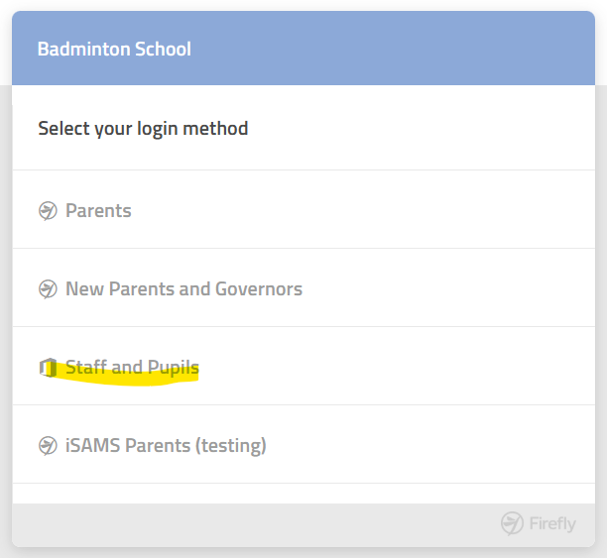

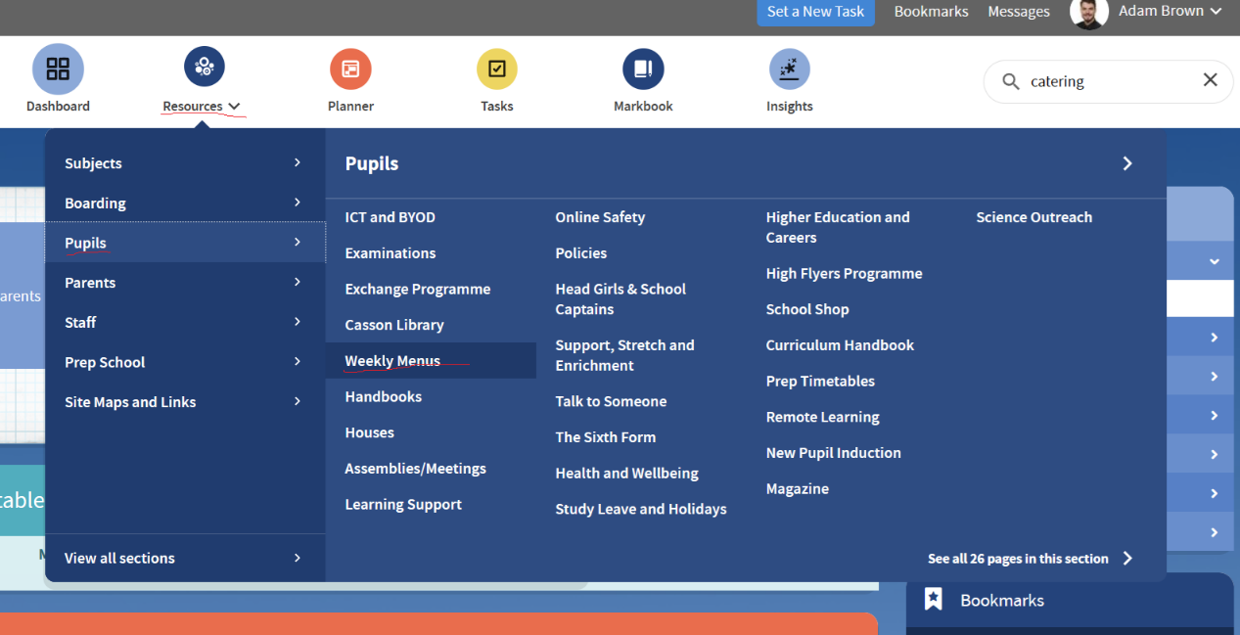
- Weekly Menus are stored here currently: https://badmintonschool.fireflycloud.net/weeklymenus/menus-2025

- You should have access to Edit the page, use the button in the bottom right corner of the screen:
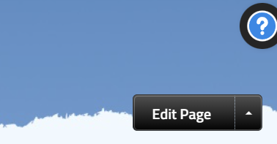

- Use the File button on the black bar that appears at the top of the screen and upload the menu into the list here. Once uploaded, select the file so it’s highlighted grey and use Add File:
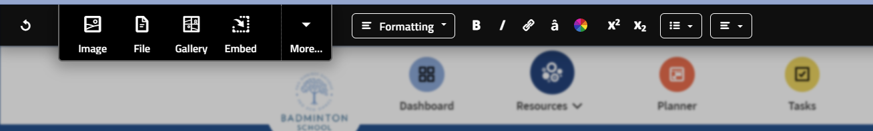
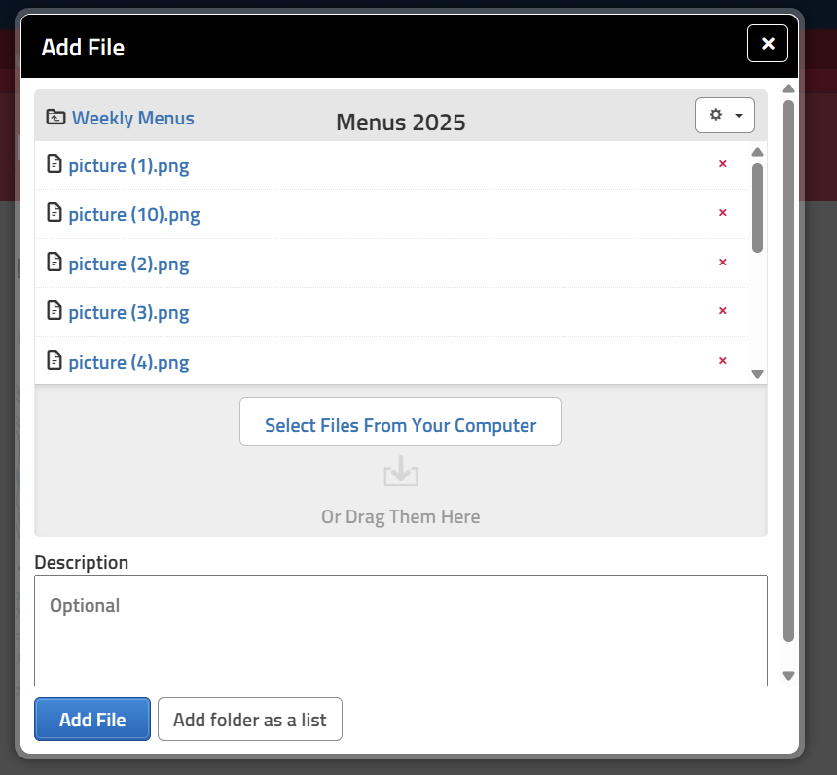
- Once added, you can move the file around and create text/headers as appropriate. Please refer to the guides here:
  - https://badmintonschool.fireflycloud.net/it-services/firefly
  - https://badmintonschool.fireflycloud.net/it-services/firefly/sample-resources-and-content

